Foundation of GenAI – LAB 1 Name: Sai Venkata Jaswant Kolupuri

Generation using Prompts. USN: 1RVU23CSE397

Date: 13-01-2025

1. Generating an email for an event

Tools: Gemini

Prompt:

You are the **IT Head of a corporate company**.  
Draft a **professional internal email** to company employees announcing an upcoming **Network Security (Firewall) Workshop**.

The email must include the following clearly labeled sections:

**1. Introduction**

* Briefly explain the importance of **network security and firewalls** in a corporate environment
* Emphasize risks such as data breaches, unauthorized access, and compliance issues

**2. Event Details**

* **Date of the event:** (use a placeholder)
* **Time:** (use a placeholder)
* **Venue / Platform:** (physical location or virtual platform placeholder)

**3. Workshop Itinerary**

* Provide a concise, time-wise agenda including:
  + Introduction to Network Security
  + Fundamentals of Firewalls
  + Common Network Threats & Attack Scenarios
  + Firewall Rules & Best Practices
  + Live Demonstration / Case Study
  + Q&A Session

**4. Required Items**

* Mention what participants need to bring or prepare (e.g., laptop, corporate VPN access, basic networking knowledge, company ID, etc.)
* Clearly state if the workshop is suitable for **both technical and non-technical employees**

**5. Call to Action**

* Encourage employees to attend and actively participate
* Include a placeholder for **registration or confirmation details**

**6. Closing**

* Close the email politely and professionally
* Sign off as **Head – Information Technology**

Tone requirements:

* Professional, authoritative, and clear
* Suitable for a mid-to-large corporate organization
* Concise but informative

Deliverable:

**Subject:** Upcoming Workshop: Network Security & Firewall Fundamentals

Date: January 13, 2026

To: All Employees

From: IT Head

Dear Team,

Please see below the details for our upcoming internal workshop focused on Network Security and Firewall infrastructure.

**1. Introduction: Why This Matters**

In today's digital landscape, the integrity of our corporate network is paramount. Firewalls serve as our first line of defense, monitoring and controlling incoming and outgoing network traffic based on predetermined security rules.

Without a robust understanding and implementation of these security measures, we expose our organization to significant risks, including:

* **Data Breaches:** Loss of sensitive client or proprietary data.
* **Unauthorized Access:** Malicious actors gaining entry to our internal systems.
* **Operational Downtime:** Disruption of business continuity due to cyberattacks.

This workshop aims to equip our team with the knowledge required to maintain a secure digital perimeter.

**2. Event Details**

* **Date:** Wednesday, January 28, 2026
* **Time:** 2:00 PM – 5:00 PM
* **Venue:** Main Conference Room B (Building 3)
* **Virtual Link:** [Insert Microsoft Teams/Zoom Link Here]

**3. Workshop Itinerary**

The session will be structured as follows:

| **Time** | **Agenda Item** |
| --- | --- |
| **2:00 PM** | **Introduction to Network Security:** The current threat landscape. |
| **2:30 PM** | **Fundamentals of Firewalls:** Packet filtering, proxy service, and stateful inspection. |
| **3:15 PM** | **Common Network Threats:** Identifying DoS attacks, IP spoofing, and malware. |
| **3:45 PM** | **Firewall Rules & Best Practices:** How to configure policies to minimize risk. |
| **4:30 PM** | **Live Demonstration / Case Study:** Real-time traffic analysis simulation. |
| **4:50 PM** | **Q&A Session:** Open floor for specific technical queries. |

**4. Required Items & Prerequisites**

To ensure a productive session, please note the following:

**What to Bring:**

* Company-issued Laptop (fully charged).
* Active Corporate VPN access (for the live demo portion).
* Employee ID badge (for physical entry to Conference Room B).

**Target Audience:**

* **Primary:** IT Support, DevOps, System Administrators, and Backend Developers.
* **Secondary:** This workshop is designed to be accessible to **non-technical staff** interested in understanding basic cybersecurity hygiene, though the 4:30 PM demonstration will be technical in nature.

**5. Call to Action**

Security is a shared responsibility. I strongly encourage all relevant technical staff to attend, and invite interested non-technical staff to join the first half of the session.

Please confirm your attendance by filling out the registration form below no later than Friday, January 24th.

**[Link: Register for Network Security Workshop Here]**

**6. Closing**

Thank you for your continued commitment to keeping our organization secure. I look forward to seeing you there.

Best Regards,

[Your Name]

Head of Information Technology

[Company Name]

1. Generating a Brochure for the event

Tools: ChatGPT’s Image Generation (DALL-E)

Prompt:

Create a clean, modern, and professional poster / one-page brochure for an internal corporate workshop titled:

“Network Security & Firewall Fundamentals”

Design style requirements:

Corporate, minimal, and professional

Suitable for an IT / cybersecurity workshop

Use a cybersecurity theme with gradients, no monotonic colours

Flat icons or subtle technical illustrations (firewall, network nodes, shield, lock)

No flashy or informal visuals

Content to include (structured clearly):

Header Section

Title: Network Security & Firewall Fundamentals

Subtitle: Internal Corporate Workshop

Why This Matters

Short summary on protecting corporate networks

Bullet points:

Data Breaches

Unauthorized Access

Operational Downtime

Event Details

Date: Wednesday, January 28, 2026

Time: 2:00 PM – 5:00 PM

Venue: Main Conference Room B, Building 3

Virtual: Microsoft Teams / Zoom

Workshop Agenda (Timeline Style)

Introduction to Network Security

Firewall Fundamentals

Common Network Threats

Firewall Rules & Best Practices

Live Demonstration

Q&A Session

Who Should Attend

IT Support, DevOps, System Administrators

Backend Developers

Interested non-technical staff

What to Bring

Company laptop

Corporate VPN access

Employee ID

Footer

Organized by: IT Department

Call-to-action: Register by January 24, 2026

Output expectations:

Portrait layout (A4 or poster size)

Readable typography with clear visual hierarchy

Suitable for email circulation, internal portals, and notice boards

Professional and enterprise-grade finish

Output:

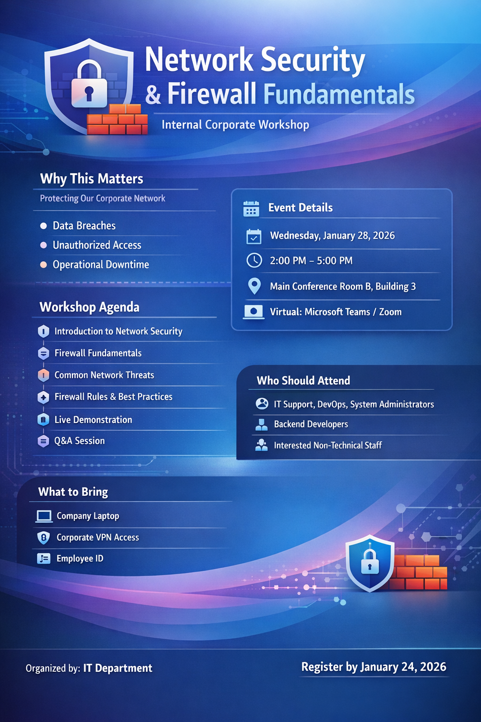

1. Generate a Video about the Event

Tool: FLIKI Ai

Prompt:

Create a **30–40 second internal corporate promo video** for an IT workshop.

**Style:** Professional, cybersecurity theme, bright gradients (teal, green, orange, blue), clean motion graphics, no flashy visuals.

**Scene 1**  
**Text:** *Is our network secure?*  
**Voiceover:** “Security threats evolve every day.”  
**Visual:** Abstract corporate network, flowing data.

**Scene 2**  
**Text:** Data Breaches | Unauthorized Access | Downtime  
**Voiceover:** “Without strong firewalls, organizations face serious risks.”  
**Visual:** Threat icons blocked by a firewall.

**Scene 3**  
**Text:** *Network Security & Firewall Fundamentals*  
*Internal Corporate Workshop*  
**Voiceover:** “This workshop builds essential firewall and network security awareness.”  
**Visual:** Shield locking into place.

**Scene 4**  
**Text:** Firewall Basics | Threats | Best Practices | Live Demo  
**Voiceover:** “Learn fundamentals, best practices, and see real-world demonstrations.”  
**Visual:** Timeline-style icons.

**Scene 5**  
**Text:** January 28, 2026 | Register by Jan 24  
Organized by IT Department  
**Voiceover:** “Join us in building a safer organization.”  
**Visual:** Secure network glow, clean close.

Output

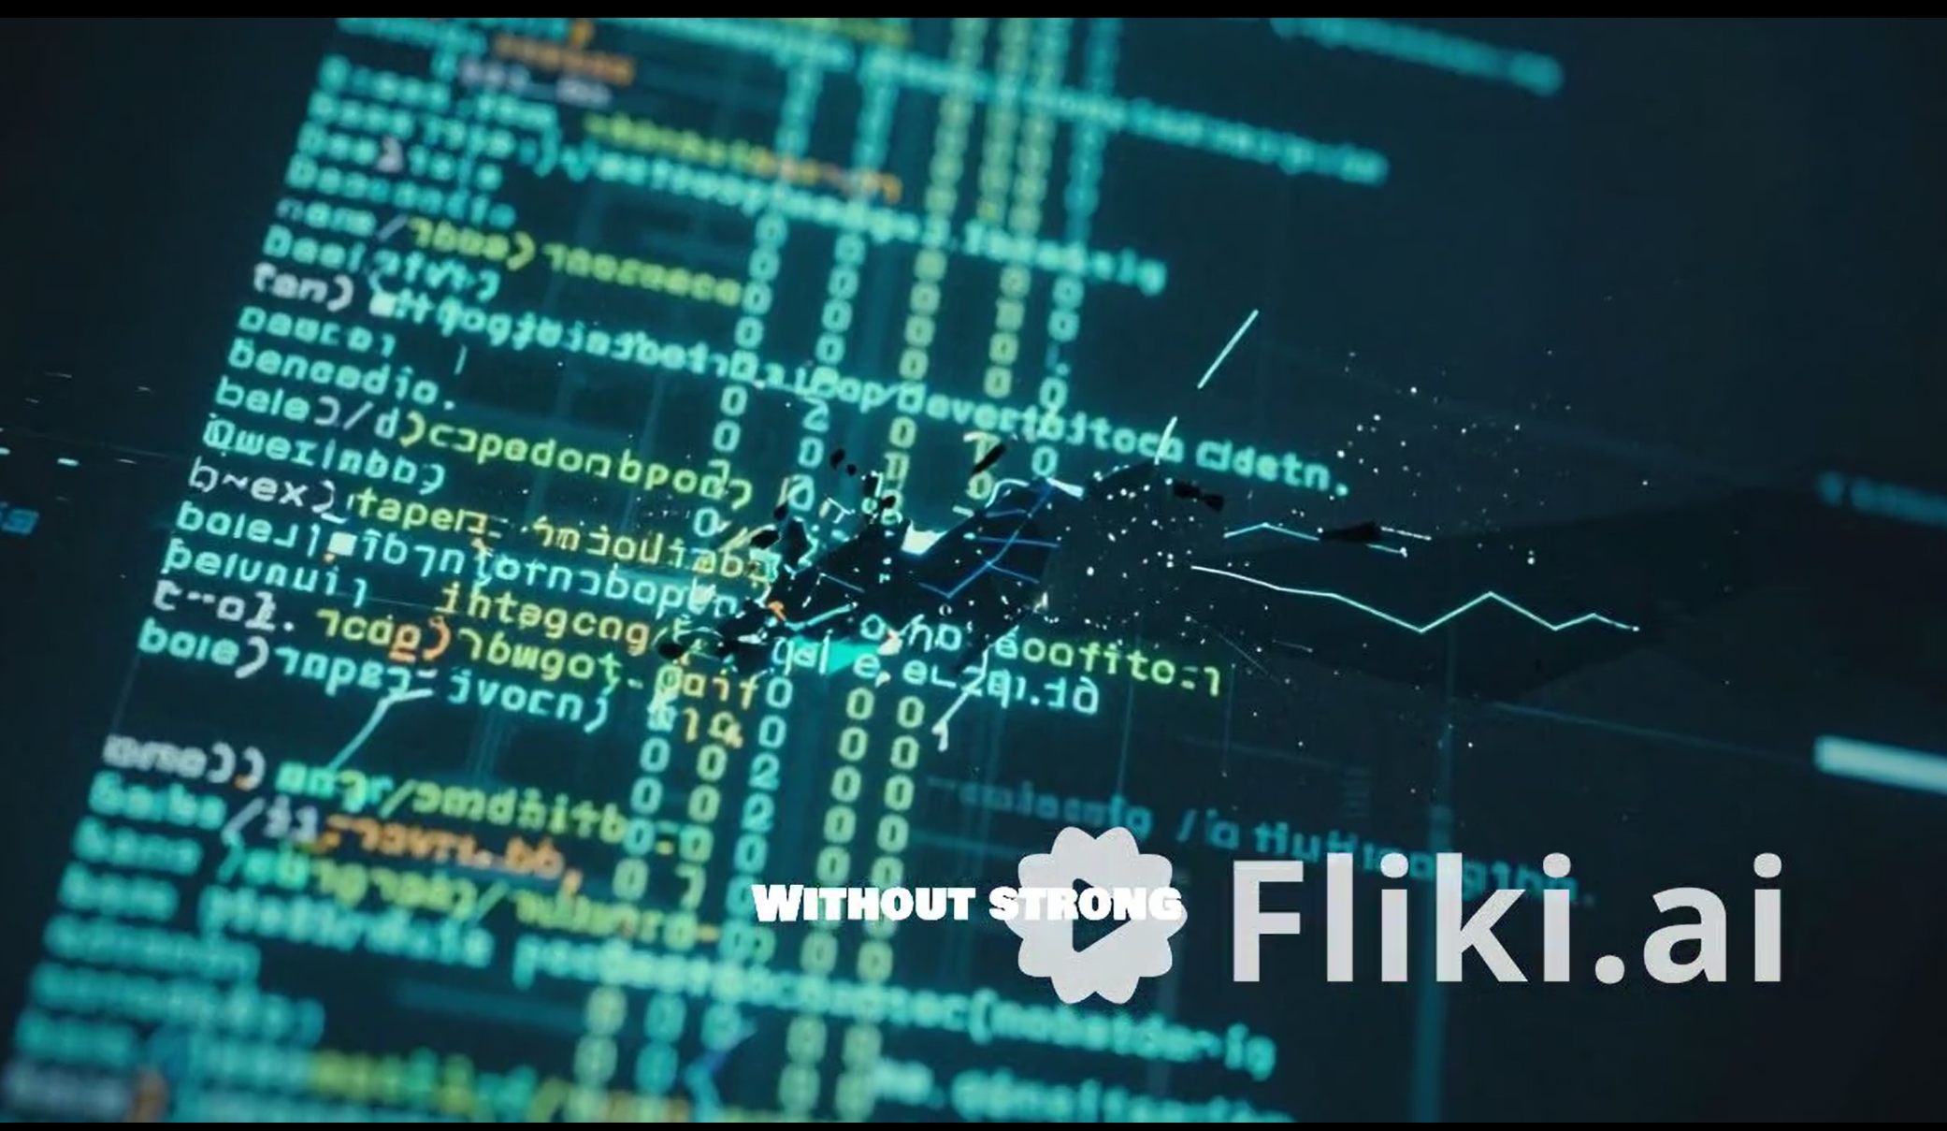

Narration Prompt: Create a **2–3 minute internal corporate explainer video** describing an upcoming IT workshop.

**Style:** Professional, informative, cybersecurity theme with bright gradients (teal, green, blue, orange). Clean motion graphics, flat icons.

**Scene Flow:**

**Intro**  
**Text:** Network Security & Firewall Fundamentals  
**Voiceover:** “This video explains the structure and objectives of our upcoming network security workshop.”  
**Visual:** Secure network animation, firewall icon.

**Why It Matters**  
**Text:** Why Network Security Matters  
**Voiceover:** “Firewalls protect corporate networks by monitoring and controlling traffic.”  
**Visual:** Threats blocked by firewall.

**Workshop Objective**  
**Text:** Workshop Objective  
**Voiceover:** “The session builds practical awareness of firewall concepts, threats, and best practices.”  
**Visual:** Checklist icons.

**Agenda Overview**  
**Text:** Network Security Basics | Firewall Fundamentals | Network Threats | Firewall Rules | Live Demo  
**Voiceover:** “The workshop covers fundamentals, common threats, firewall policies, and a live demonstration.”  
**Visual:** Timeline-style icons.

**Audience**  
**Text:** Who Should Attend  
**Voiceover:** “Ideal for IT teams and non-technical staff interested in cybersecurity basics.”  
**Visual:** Role icons connected securely.

**Preparation**  
**Text:** What to Bring  
**Voiceover:** “Bring a company laptop, VPN access, and employee ID.”  
**Visual:** Laptop, lock, ID icons.

**Close**  
**Text:** Jan 28, 2026 | Register by Jan 24  
Organized by IT Department  
**Voiceover:** “We look forward to strengthening our security together.”  
**Visual:** Clean professional close.

Output

